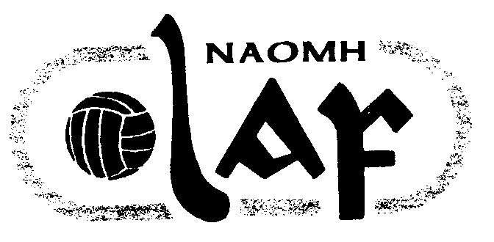
NAOMH OLAF GAA CLUB
Peil (Football)/ Iomaint (Hurling) Fixtures 2004
WEEK ENDING 31ST JANUARY

Roinn  (Age) | La  (Date) | Am  (Time) | I gCoinne  (Opposition) | Ionad  (Venue) | Comortas  (Competition) | Reiteoir  (Referee) | Toradh  (Result)
U 9 F | Sat 31st | 11.00 | Kilmacud Crokes | Oatlands College |  | Rowan/Sweeney
U 10 F | Sat 31st | 11.15 | Ballyfermot DLS | Pairc Ui Bhriain | Plate | C Duffy | Win 12-3 to 2-0
U 11 F | Sat 31st | 10.30 | Ballinteer St John’s | Marley Park | Plate | C Traynor | Off
U 12 F | Sat 31st | 12.30 | Liffey Gaels | Pairc Ui Bhriain | Plate | C Duffy | Win 5-7 to 4-0
U 13 | Sat 31st | 1.45 | Naomh Barrog | St Anne’s No 12 | Cup | B Concannon | Off
U 14 | Sat 31st | 2.30 | Clontarf | Pairc Ui Bhriain | Cup | None given | Off
U 16 F | Sat 31st | 2.30 | Raheny | Pairc Ui Bhriain | League | None given | Win 2-6 to 2-4

